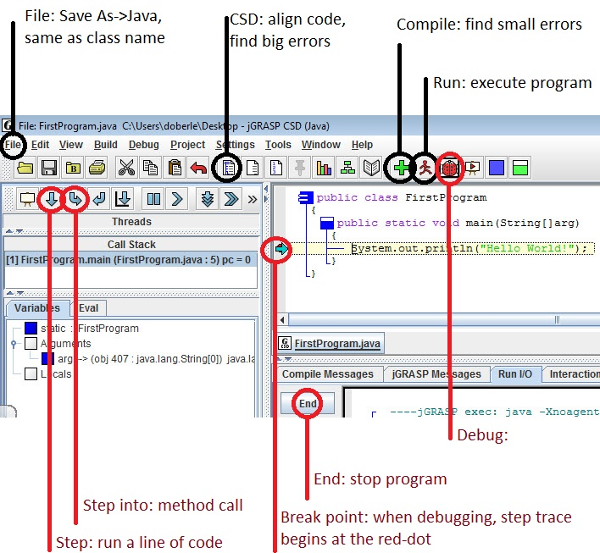 **File**: save as a Java file with the same name as the public class name.

**CSD**: finds big errors, like unmatched parenthesis, braces and brackets. Aligns your code to make it easy to read.

**Compile**: finds small errors, like missing semicolon, spelling and case-sensitivity issues.

**Run**: executes last successful compile.

**Debug**: if your program compiles but does not execute correctly, you can run the program one

line at a time and watch the variables change with the debugger. Set up a break point

at the part of the program you want to debug, hit the Debug button and step through

the code to find the logical error.

**Break Point:** along the left border of the code window, toggle red-dot for a break point where

you want to start debugging.

**Step:** when debugging, step will execute a single line of code

**Step into:** when debugging, step into will enter a method call to allow you to debug within.

**End:** halt a program if you have an infinite loop.